There is an option to send a bug report which attempts to send an e-mail. For some reason I can’t get Outlook to run in GBDS VDI (I’m getting a server not available message) so I can’t see what P21 is trying to send.

I’ve just given you access to run P21 and would like you to give it a go…Here are the steps:

1) Double-click the P21 executable in \\am.corp.amgen.com\apps\CDA\UserData\stat\statlib\sps_prod\apps\pinnacle21\community

2) Click the Validator icon:

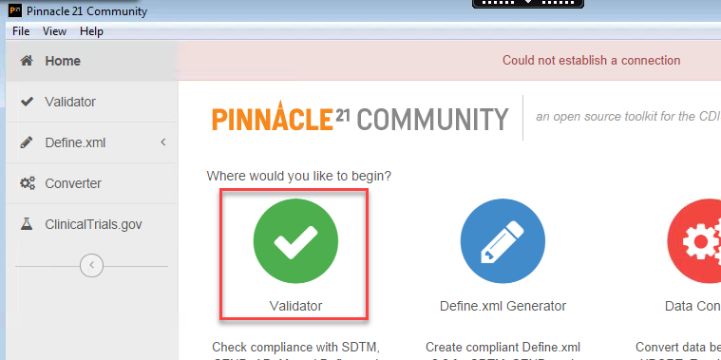

3) Change the Standard to Define.xml, select the file shown below (or any define.xml file), and click the Validate button:

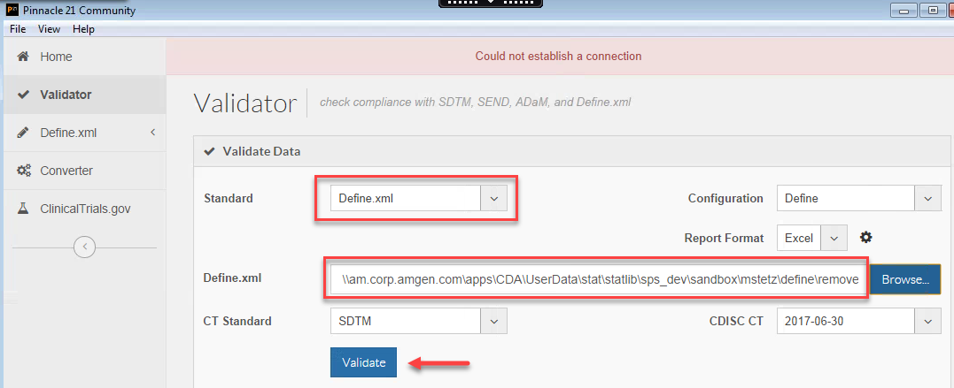

4) Assuming you get the error, click the Send Bug Report button:

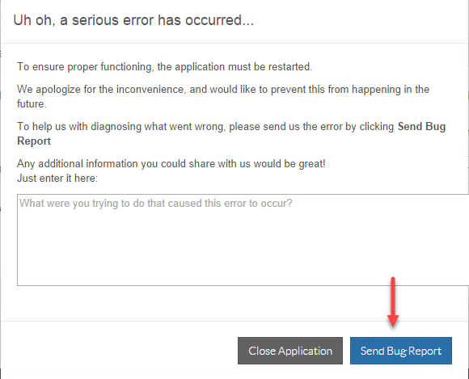

From there, see if there is anything in the bug report e-mail that provides a clue to the issue and perhaps pass that along to the CTS-SAS team (who I’ve copied in for awareness as we’ve received a couple of ISM incidents for this today -- attached).

